35. Basics of Test Class - 19 Nov 2021

Two Purposes,

1] Code Coverage Minimum Code Coverage (Apex Class 75%), Trigger – 1%

2] Tally / Verify the Business Logic

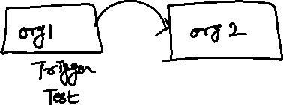

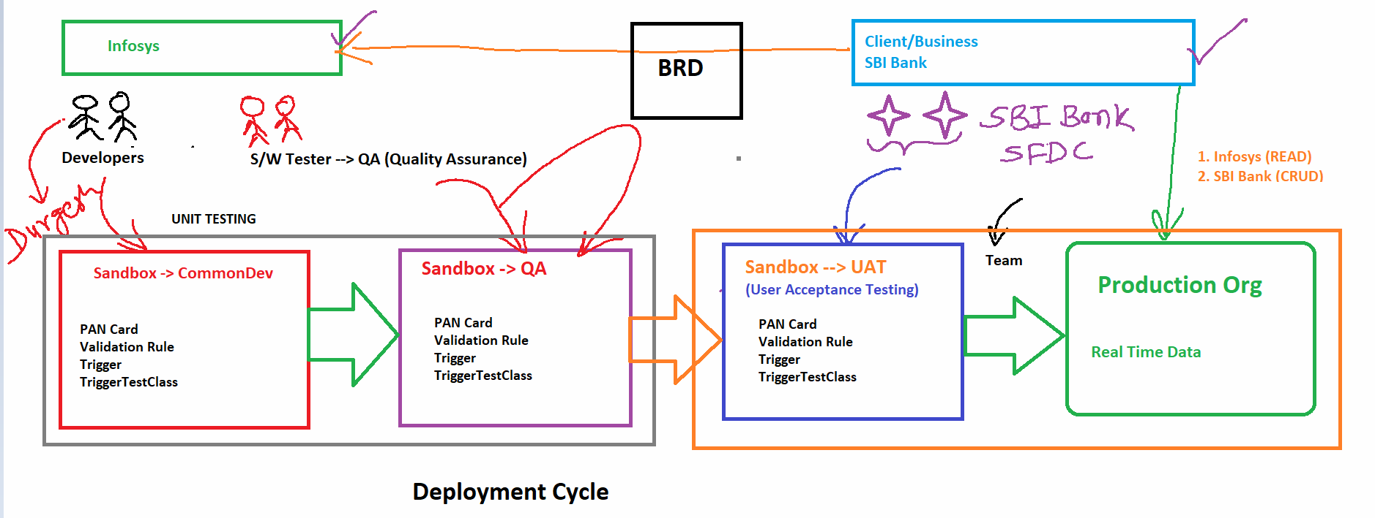

public class Car {

public Integer addition (Integer x, Integer y){

return (x+y);

}

}



Test Class:

@isTest

public class CarTest {

}

public class Car {

public static Integer addition (Integer x, Integer y){

return (x+y);

}

public static Integer multiplication(Integer x, Integer y){

return (x\*y);

}

}

@isTest

public class CarTest {

@isTest

public static void TestAdditionMethod(){

Integer result = Car.addition(10, 20);

}

@isTest

public static void TestMultiplicationMethod(){

Integer result = Car.multiplication(10, 20);

}

}

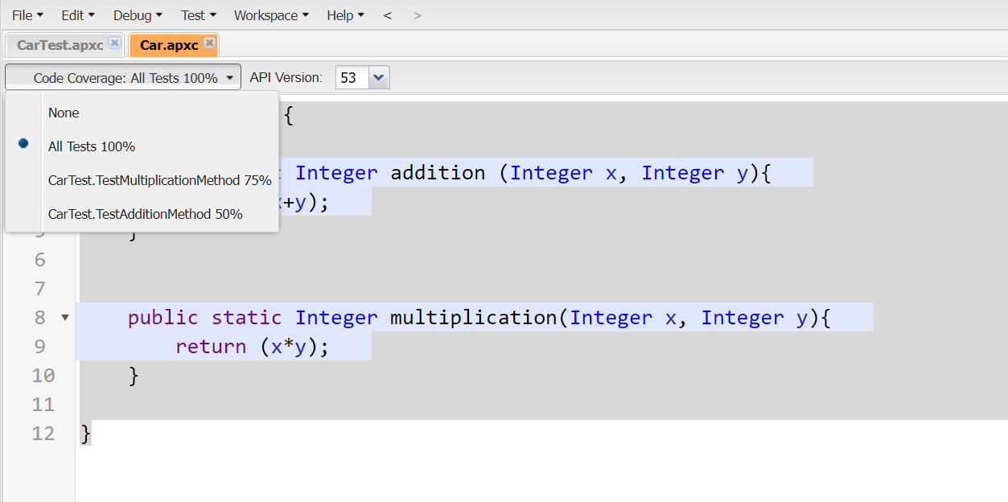

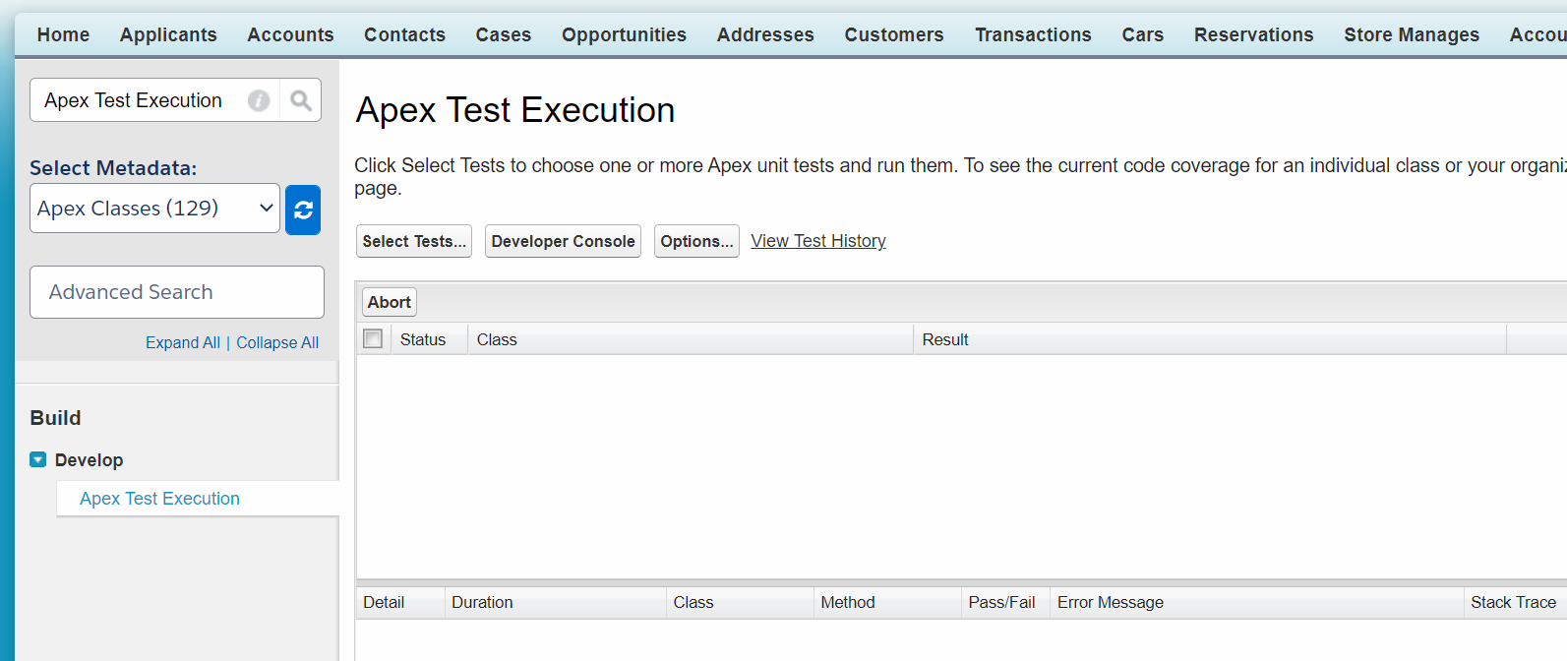

public class Car {

public static Integer addition (Integer x, Integer y){

return (x+y);

}

public static Integer multiplication(Integer x, Integer y){

return (x\*y);

}

}

@isTest

public class CarTest {

@isTest

public static void TestAdditionMethod(){

Integer result = Car.addition(10, 20);

System.assertEquals(30, result);

}

@isTest

public static void TestMultiplicationMethod(){

Integer result = Car.multiplication(10, 20);

System.assertEquals(200, result) ;

}

}

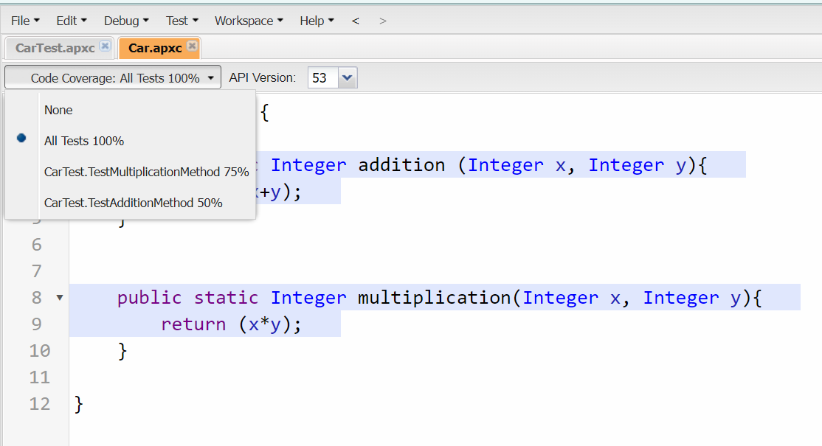

public class Insurance {

public String prefixName(String Name, String Gender){

String finalName;

if(Gender=='Male'){

finalName = 'Mr.'+Name;

}

else{

if(Gender=='Female'){

finalName = 'Ms.'+Name;

}

}

return finalName;

}

}

@isTest

public class InsuranceTest {

@isTest

public static void TestPrefixMrMethod(){

String resultName = new Insurance().prefixName('Bunty', 'Male');

System.assertEquals('Mr.Bunty', resultName);

}

@isTest

public static void TestPrefixMsMethod(){

String resultName = new Insurance().prefixName('Bubli', 'Female');

System.assertEquals('Ms.Bubli', resultName);

}

}

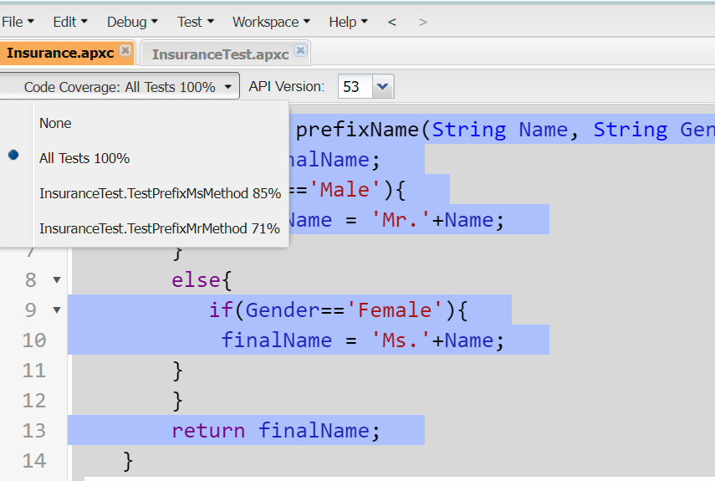

public class IncomeTaxCal {

public static Decimal IncomeTax(Decimal Salary, Decimal Roi){

return (Salary\*Roi)/100;

}

}

@isTest

public class IncomeTaxCalTest {

public static testMethod void incomeTaxCalTestMethod(){

Decimal incomeTaxResult = IncomeTaxCal.IncomeTax(50000,7);

System.assertEquals(3500, incomeTaxResult) ;

}

}

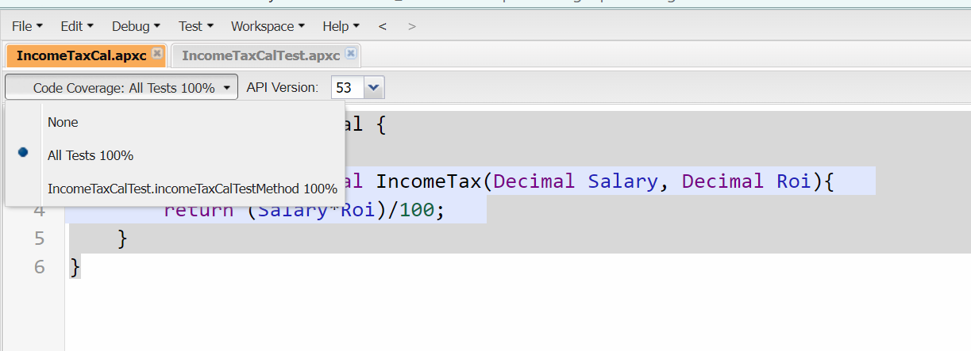

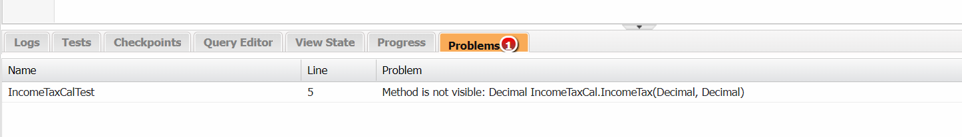

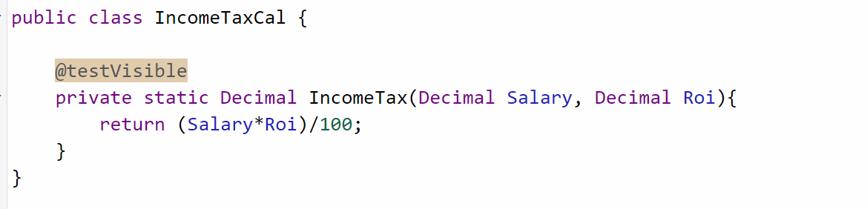

Code:

VF Extension : Coding

Apex Class : Coding

Trigger : Coding

Batch Class : Coding